**Assignment 5**

**Q1) Explain UDP Header Format.**

**Ans)** UDP header is **8-bytes** fixed and simple header, while for TCP it may vary from 20 bytes to 60 bytes. First 8 Bytes contains all necessary header information and remaining part consist of data. UDP port number fields are each 16 bits long, therefore range for port numbers defined from 0 to 65535; port number 0 is reserved. Port numbers help to distinguish different user requests or process.

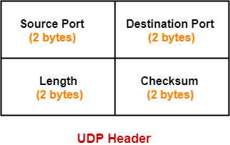

**1. Source Port-**

* Source Port is a 16 bit field.
* It identifies the port of the sending application.

**2. Destination Port-**

* Destination Port is a 16 bit field.
* It identifies the port of the receiving application.

**3. Length-**

* Length is a 16 bit field.
* It identifies the combined length of UDP Header and Encapsulated data.

|  |
| --- |
| Length = Length of UDP Header + Length of encapsulated data |

**4. Checksum-**

* [**Checksum**](https://www.gatevidyalay.com/checksum-checksum-example-error-detection/) is a 16 bit field used for error control.
* It is calculated on UDP Header, encapsulated data and IP pseudo header.
* Checksum calculation is not mandatory in UDP.

**Q2) Explain TCP/IP Header Format.**

## Ans) TCP Header-

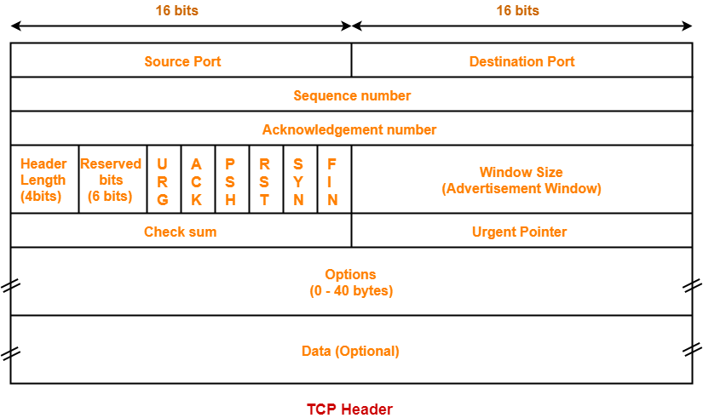

**1. Source Port-**

* Source Port is a 16 bit field.
* It identifies the port of the sending application.

**2. Destination Port-**

* Destination Port is a 16 bit field.
* It identifies the port of the receiving application.

**3. Sequence Number-**

* Sequence number is a 32 bit field.
* TCP assigns a unique sequence number to each byte of data contained in the TCP segment.
* This field contains the sequence number of the first data byte.

**4. Acknowledgement Number-**

* Acknowledgment number is a 32 bit field.
* It contains sequence number of the data byte that receiver expects to receive next from the sender.
* It is always sequence number of the last received data byte incremented by 1.

**5. Header Length-**

* Header length is a 4 bit field.
* It contains the length of TCP header.
* It helps in knowing from where the actual data begins.

## 6. Reserved Bits-

* The 6 bits are reserved.
* These bits are not used.

**7. URG Bit-**

URG bit is used to treat certain data on an urgent basis.

When URG bit is set to 1,

* It indicates the receiver that certain amount of data within the current segment is urgent.
* Urgent data is pointed out by evaluating the urgent pointer field.
* The urgent data has be prioritized.
* Receiver forwards urgent data to the receiving application on a separate channel.

**8. ACK Bit-**

ACK bit indicates whether acknowledgement number field is valid or not.

* When ACK bit is set to 1, it indicates that acknowledgement number contained in the TCP header is valid.
* For all TCP segments except request segment, ACK bit is set to 1.
* Request segment is sent for connection establishment during [**Three Way Handshake**](https://www.gatevidyalay.com/three-way-handshake-tcp-connection-establishment/).

**9. PSH Bit-**

PSH bit is used to push the entire buffer immediately to the receiving application.

When PSH bit is set to 1,

* All the segments in the buffer are immediately pushed to the receiving application.
* No wait is done for filling the entire buffer.
* This makes the entire buffer to free up immediately.

**10. RST Bit-**

When RST bit is set to 1,

* It indicates the receiver to terminate the connection immediately.
* It causes both the sides to release the connection and all its resources

abnormally.

* The transfer of data ceases in both the directions.
* It may result in the loss of data that is in transit.

 This is used only when-

* There are unrecoverable errors.
* There is no chance of terminating the TCP connection normally.

**11. SYN Bit-**

SYN bit is used to synchronize the sequence numbers.

  When SYN bit is set to 1,

* It indicates the receiver that the sequence number contained in the TCP header is the initial sequence number.
* Request segment sent for connection establishment during Three way handshake contains SYN bit set to 1.

**12. FIN Bit-**

FIN bit is used to terminate the TCP connection.

When FIN bit is set to 1,

* It indicates the receiver that the sender wants to terminate the connection.
* FIN segment sent for [**TCP Connection Termination**](https://www.gatevidyalay.com/tcp-connection-termination-tcp-protocol/)contains FIN bit set to 1.

**13. Window Size-**

* Window size is a 16 bit field.
* It contains the size of the receiving window of the sender.
* It advertises how much data (in bytes) the sender can receive without acknowledgement.
* Thus, window size is used for [**Flow Control**](https://www.gatevidyalay.com/flow-control-stop-and-wait-protocol/).

**14. Checksum-**

* Checksum is a 16 bit field used for error control.
* It verifies the integrity of data in the TCP payload.
* Sender adds CRC checksum to the checksum field before sending the data.
* Receiver rejects the data that fails the CRC check.

**15. Urgent Pointer-**

* Urgent pointer is a 16 bit field.
* It indicates how much data in the current segment counting from the first data byte is urgent.
* Urgent pointer added to the sequence number indicates the end of urgent data byte.
* This field is considered valid and evaluated only if the URG bit is set to 1.

**16. Options-**

* Options field is used for several purposes.
* The size of options field vary from 0 bytes to 40 bytes.

 Options field is generally used for the following purposes-

1. Time stamp
2. Window size extension
3. Parameter negotiation
4. Padding

**Q3) Explain**